Lab 4: BUTT Wireless Sensor Network

Joshua Bainbridge 250869629

**Part 1: Problem statement**

Design a wireless sensor network to track an animal population and monitor environmental conditions

in a given habitat.

**Part 2: Overview and Protocol**

In an attempt to minimize cost along with the limitations that arose as a result of the locations of the power outlets the system was designed as a heterogeneous WSN. The network will be deployed as a structured non-random deployment. This was selected because of the small size of the area, the structure of the building (hallways into rooms) along with the assumptions that were made about how the sensors would work. The majority of the network has a k-connectivity of at least 2. However there are locations within the system that have a k of 1. These nodes could cause parts of the network to go dark. As a result these nodes were gives twice the battery power as other nodes, and two hundred dollars was left in the budges to replaces these nodes if required. The WSN is designed to last at least one school year before needing to be replaced. Assuming failing nodes will be as a result of loss of power and not hardware malfunction it is likely the Zigbee component of the WSN my need to be checked after one school year. However the Z-wave nodes are plugged into the wall outlets. As a result this part of the WSN has a much longer expected operating lifespan.

A Zigbee protocol was implemented for areas in the network where sensors where close together and in location where power outlets are scares. From the most part the Zigbee WSN controls the pressure sensors in the hallways and smaller rooms. Z-wave nodes are deployed in larger rooms generally using light and humidity sensors.

**Part 3: Sensors**

**Light**: The WSN is deployed with the assumption that light in rooms is relatively uniform in each room. To ensure this larger rooms will have two sensors deployed on opposite sides to gage an accurate measurement of the light. The nodes with photo sensors will be mounted on the wall and roughly head or table height. This is the best way to gage the light level undergraduate students prefer.

**Humidity**: Similar to the photosensors it is assumed that humidity is roughly uniform in a room. Two humidity sensors are placed in larger rooms to ensure this assumption is correct. The humidity sensor is also places on the wall at head or table height to best gage the humidity preferred by undergraduate students.

**Pressure**: Pressure sensors are placed at every room entrance and exit. The researchers want to know the migrations patterns of undergraduate students. This means it is not necessary for pressure pads to be placed within the rooms. By placed the pressure pads in the entrance and exit to each room the number and direction of travel of students can be measured.

**Part 4: Nodes**

|  |  |  |  |  |
| --- | --- | --- | --- | --- |
| Node | Power | Sensors | Location | Protocol |
| HUB | Power outlet  Ethernet | Light  Humidity | Wall | Zigbee Controller  Z-Wave |
| Zig.R.W.# | High Cap Battery | Light  Humidity | Wall | Zigbee Router |
| Zig.R.C.# | High Cap Battery | None | Ceiling | Zigbee Router |
| Zig.R.C.# | High Cap Battery | Pressure | Floor | Zigbee Router |
| Zig.E.F.# | High Cap Battery | Pressure | Floor | Zigbee End |

**Part 5: Network Deployment**

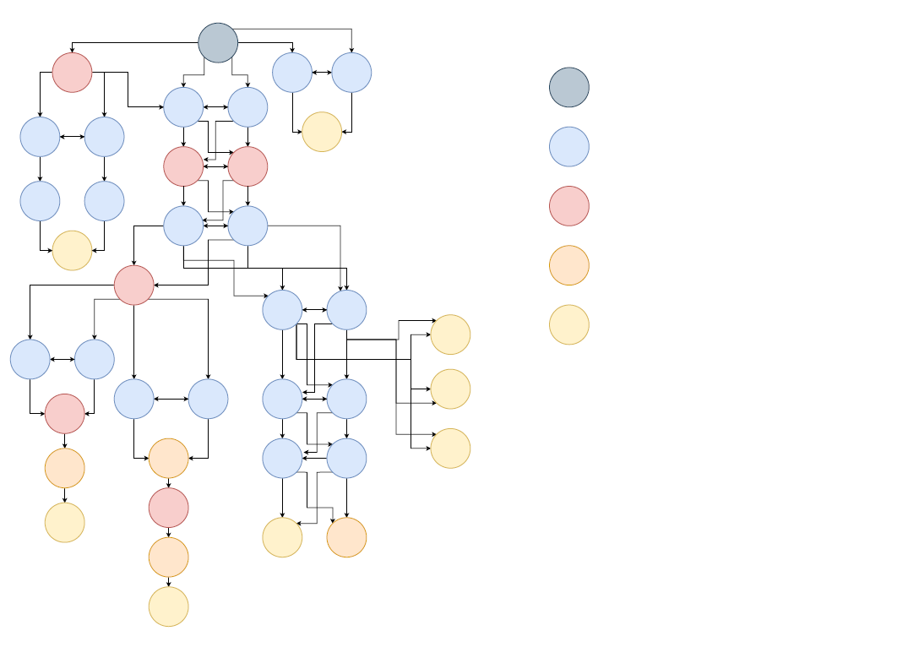

HUB

Router Node 🡪 on ceiling, no sensors

Router Node 🡪 on floor, pressure sensors

End Node 🡪 on floor, pressure sensors

Router Node 🡪 on wall, light, and humidity sensors

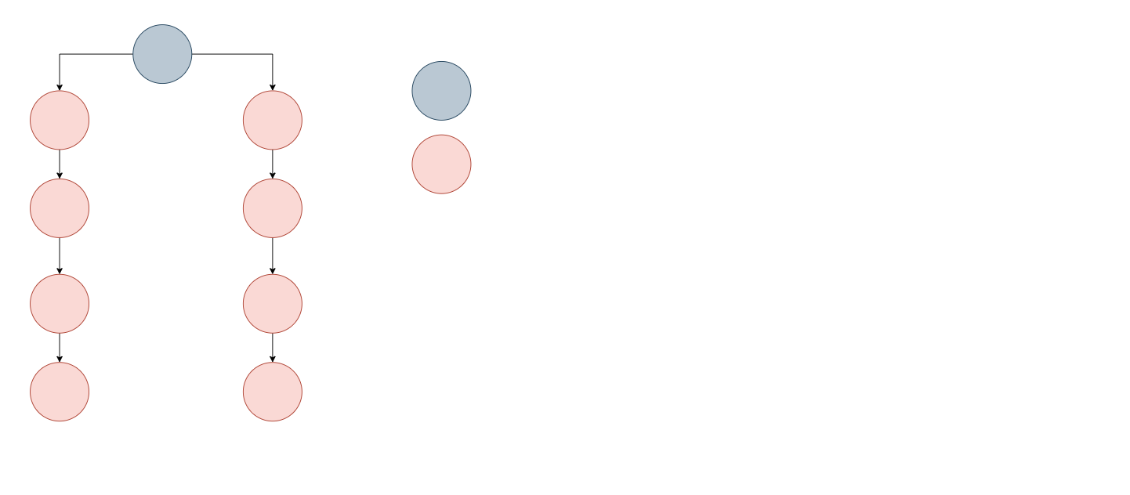

HUB

Z-Wave Node 🡪 on wall, light, and humidity sensors

The diagrams above show how the connectivity of the network is set up for both the Zigbee and Z-Wave protocols. The HUB is the only node that is overpowered to cover 90 m. Additionally a map of the sensor coverage and communication radius can be found in the Appendix. All pressures sensor nodes have been placed on the floor. All nodes with light and humidity sensors are place at head or table height on the wall to ensure the measurements are similar to the light levels and humidity experienced by students in the area. Finally any node used only to allow for communication are mounted on the ceiling to keep them out of the way of students.

**Part 6: Operating Protocols**

Light and humidity data should be collected once or twice an hour. Since the area is located in a basement the light levels are unlikely to change much during the day. The only factor will be which lights are turned on. Pressures sensors should use an interrupt protocol during normal school hours when lots of data will be collected over a short period of time. In late and early hours of the day the data should be stored on the microcontroller and sent once an hour. This is don’t to minimize power used each day.

Interference was prevented by separating the pressure sensor from other sensors. This was also done because the pressure sensors are placed on the floor and are likely to be blocked or damaged by student traffic.

The light and humidity sensors simply measure the light and humidity levels in the room. The pressure sensors aim to measure the number of people entering a room. All of the above with measure quantitative values. The force applied on the pressure senor maybe allow researchers to estimate the number of students stepping on the pressure senor at one time. The acquired data from the pressure sensors will give an estimate of the population in a given room and the migration of students between rooms.

**Part 7: Strengths and Weaknesses**

One of the strengths of the network is the efficient deployment of the system. The network uses the minimum number of sensors required to measure light, humidity, and pressure. This has allowed for most of the Zigbee network router nodes to be doubled up to maximize the connectivity and robustness. To minimize the chance of a pressure sensor being missed each pressure node has two pressure sensors to maximize the sensing area. This can be done because pressure nodes are located on the ground and do not contain light or humidity sensors. Additionally the Z-wave network is able to use only wall outlets to power the nodes. One weakness of the network is some sections have a k-connectivity of 1. Additionally the network cannot determine where in the room’s students are gathering.

Part 8: Cost

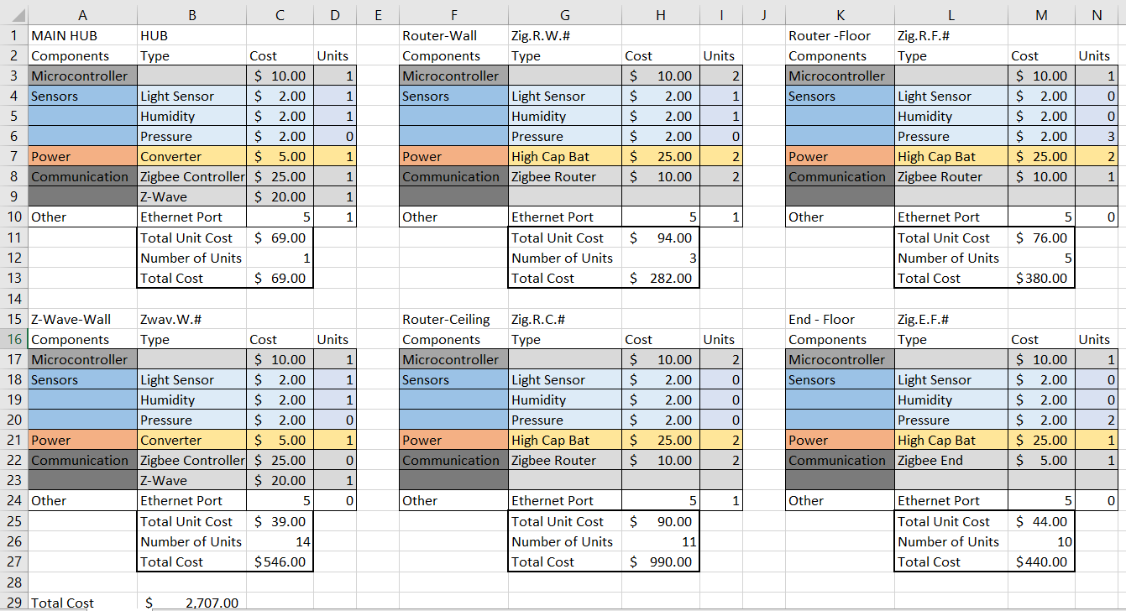

Map of Nodes

APPENDIX

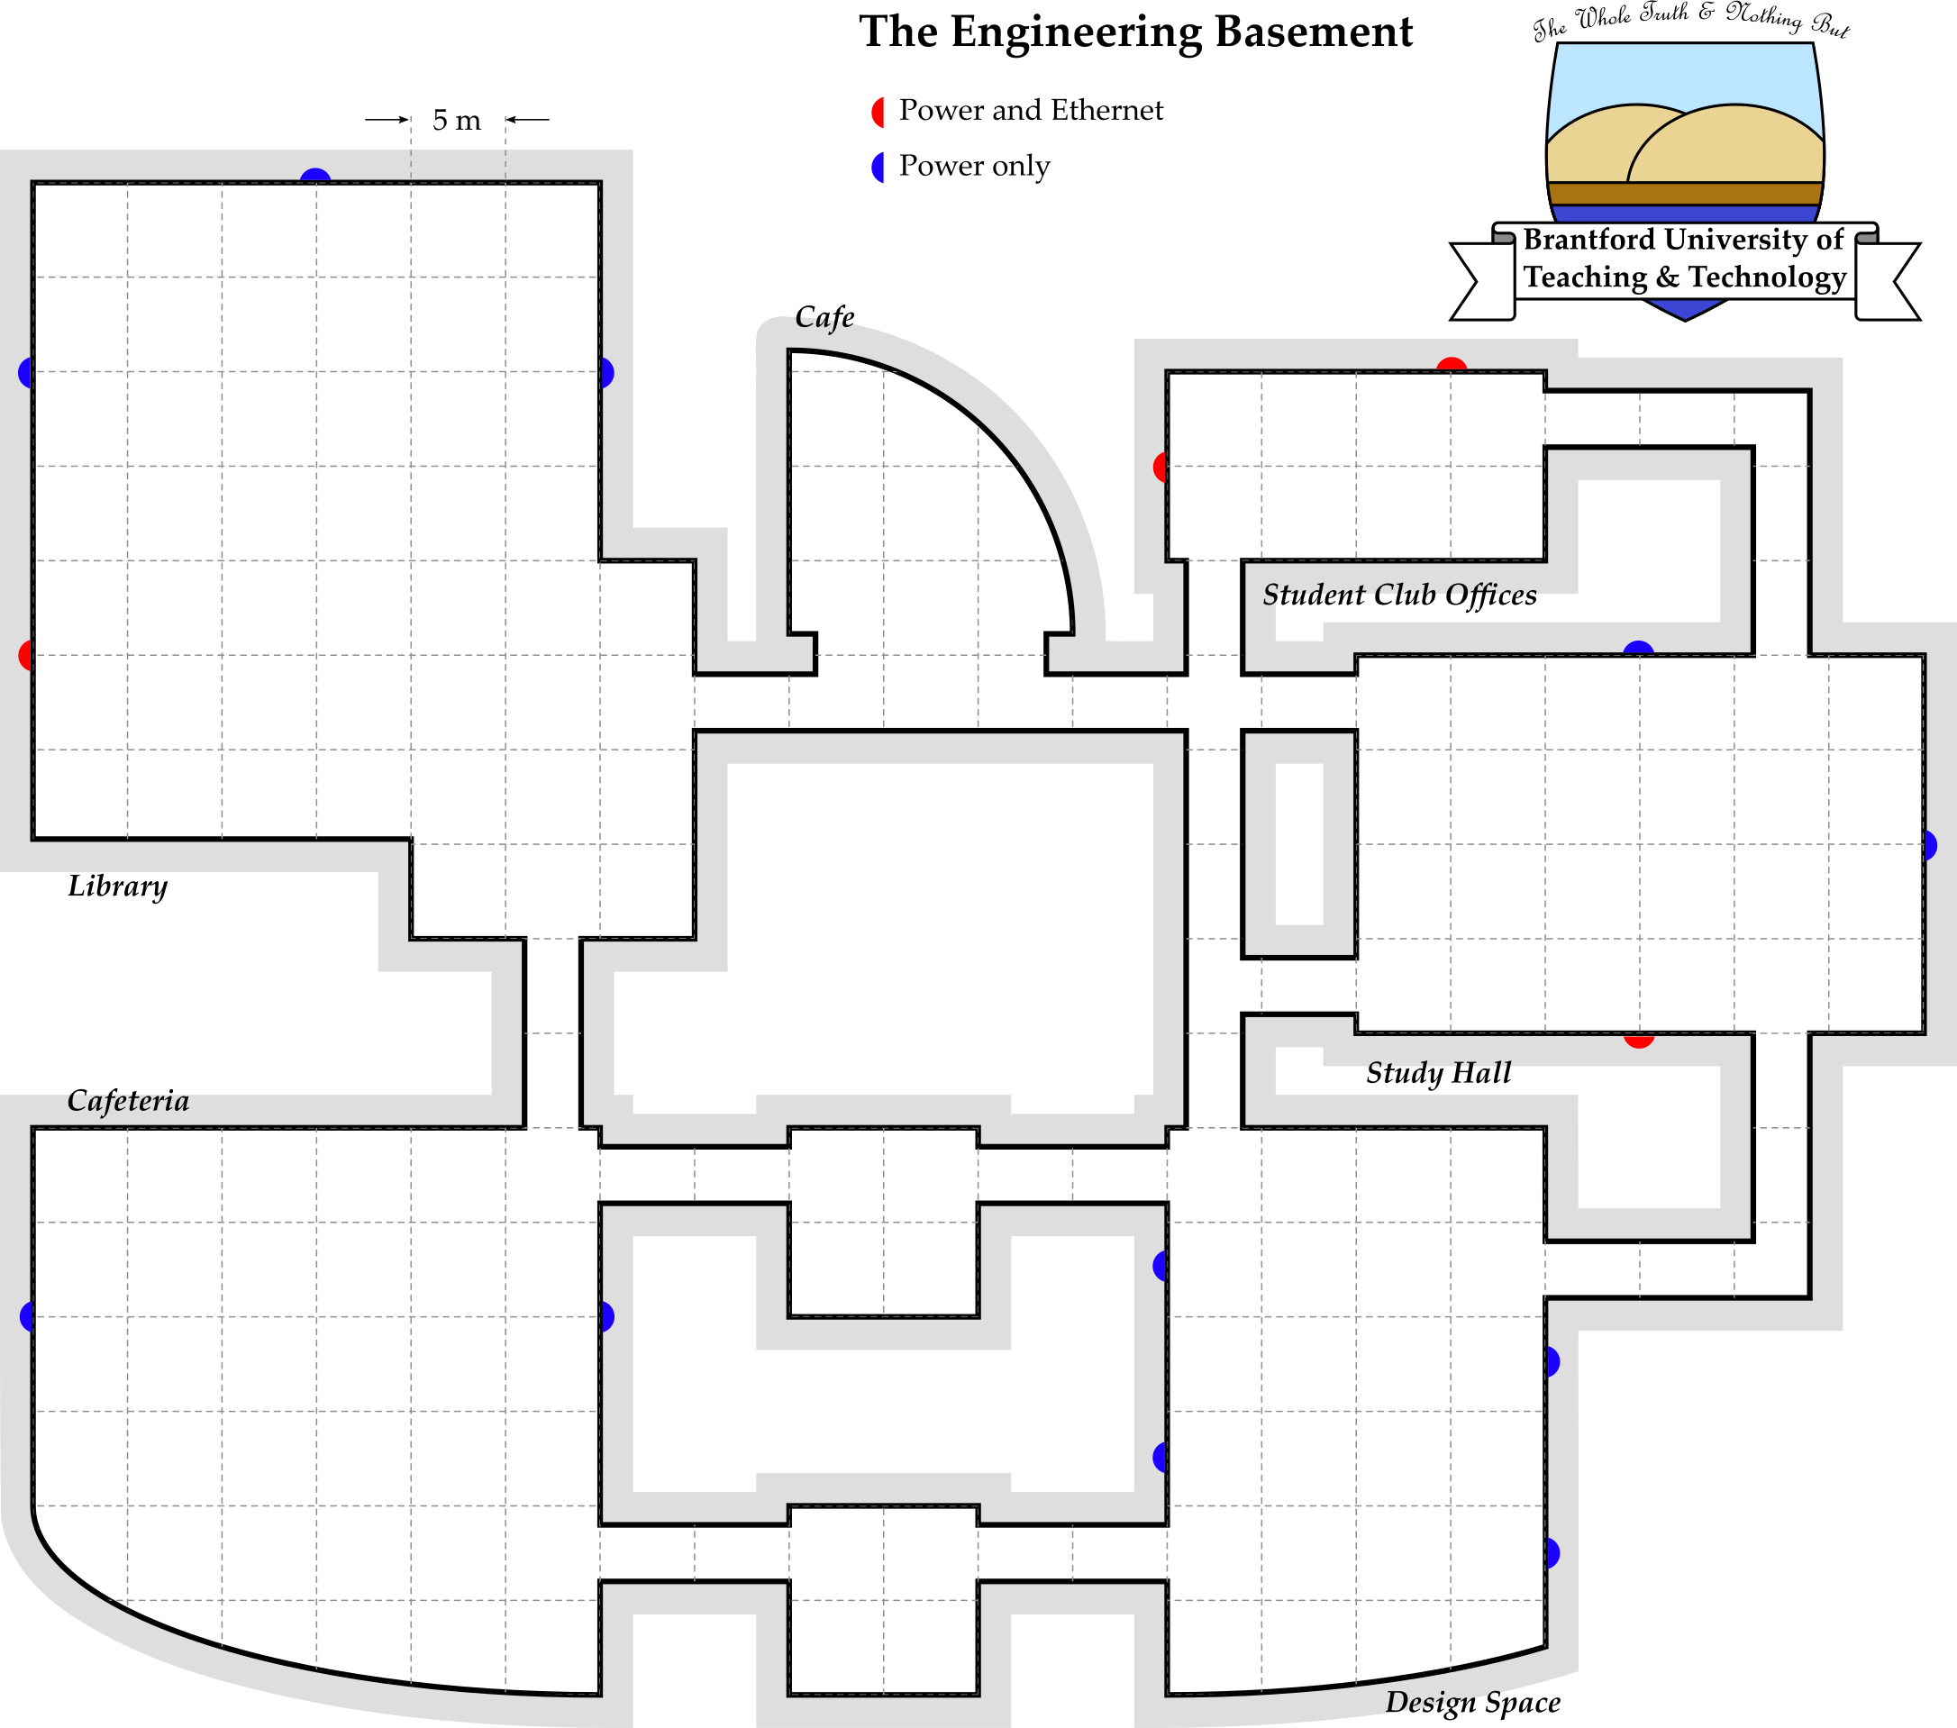

Zwav.W.8

Zwav.W.7

Zwav.W.6

Zwav.W.5

Zwav.W.4

Zwav.W.3

Zwav.W.2

Zwav.W.1

HUB

Zig.E.F.1

Zig.E.F.2

Zig.E.F.3

Zig.E.F.4

Zig.E.F.7

Zig.E.F.9

Zig.E.F.8

Zig.E.F.10

Zig.E.F.6

Zig.E.W.1

Zig.E.W.2

Zig.E.W.3

Zig.R.F.1

Zig.R.F.2

Zig.R.F.3

Zig.R.F.5

Zig.R.F.5

Zig.R.C.1

Zig.R.C.2

Zig.R.C.3

Zig.R.C.4

Zig.R.C.6

Zig.R.C.7

Zig.R.C.8

Zig.R.C.9

Zig.R.C.10

Zig.R.C.11

Map of Sensor Coverage



Connectivity of Z-wave



Connectivity of Zigbee

